

Table of Contents

Response to

Remote Team Extension/ Managed Services RFI

Presented To: CME Group

**Version: 1.0 | Date: Feb 7, 2012**

1 Range of Services 4

2 Industry & Technology Experience 6

2.1 Capital Market & Asset Management Capabilities 6

2.2 JAVA Capabilities 10

2.3 Quality Assurance and Testing Services (QATS) Capabilities 11

3 Locations 14

4 Recruiting & Retention 16

5 Quality & Project Management 17

5.1 Project Management 17

5.2 Quality @ Hexaware 23

6 Team Engagement 26

6.1 Escalation Mechanism 28

7 Rate Card 29

8 Exceptions 30

9 Appendix a: Vendor Profile 31

9.1 Background 31

9.2 User references 33

10 Exhibit a: Master Consultant Agreement 34

11 Exhibit B: InfoSEc Vendor Questionnaire 35

12 Exhibit C: Rate Card 36

Executive Summary

Shreyas to Fill

# Range of Services

Hexaware proposes **Hybrid Delivery – Onsite / Near-shore / Offshore Model** for the engagement with CME Group.

In **Offshore/ Near-shore / Onsite (Hybrid) Delivery Model**, the outsourcing work is distributed between the service provider’s onsite center, near-shore center and the offshore development center. Thereby the client gets the advantage of both outsourcing models. It is one of the most successful and popular outsourcing models employed today by many companies. The distribution of work depends on the type of project. Usually 20-30% of the work is done at the onsite center and the rest of it is done by the offshore & Near-shore development center.

Generally, the tasks accomplished at the onsite include

* Gathering initial information about the project through direct interaction with the client.
* Understanding the requirements/specifications clearly.
* Planning and initial designing as to how the project will go about.
* Interact directly with the clients to accommodate any changes, if any, so as to minimize/eliminate any last minute changes.
* Execution/Implementation of the project in accordance with the client’s expectations and making sure that the client is fully satisfied with the end results.
* Dealing with the client and managing partnership.

Along with being able to gain benefits from the same time zone, the near-shore is able to accomplish the below tasks:

* Rapid availability and deployment of near-shore resources to CME’s Chicago office
* Ability to be able to support go-live situations
* Troubleshooting and mitigating critical situations
* Travel for short durations involving a particular phase of the project like system and integration testing

Tasks accomplished at the offshore development center include

* Understanding the specifications and coming up with a detailed design.
* Responsibility for the progress of the project.
* Ensuring that the outcome matches the specifications given by the client.
* Crucial and continuous support to the onsite center.

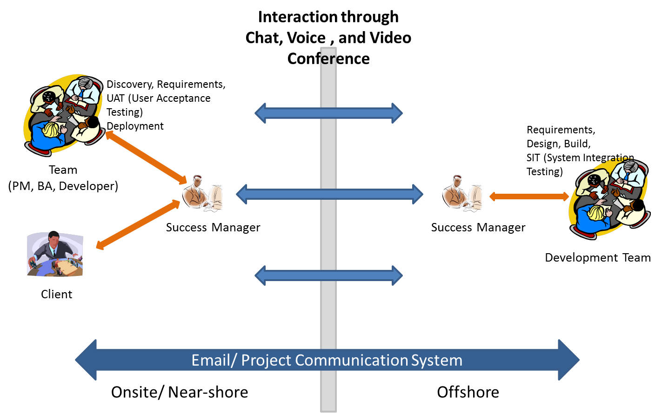

**Advantages of Onsite/ Near-shore / Offshore Delivery Model**

* Direct dealings with the client: Direct interaction with the client is possible through the onsite and near-shore center. Therefore there is no possibility of a communication gap. Along with this the service provider gets a better picture of the client’s needs.
* 24/7 productivity: Round the clock continuous work cycle becomes possible by making the best possible use of the time-zone differences.
* Access to the most excellent resources: Client can have access to the best technology, skilled manpower and equipment possible made available to them by the near-shore and offshore development center.
* Great cost benefits: Cost savings resulting from majority of the work being outsourced to the near-shore and offshore development center where the resources are comparatively cheaper.
* Best possible management of resources: Usage efficiency of resources is the highest with this model.
* Onsite -Near-shore-Offshore Connectivity.

Onsite / Near-shore / Offshore model is generally preferred in cases where the project is complicated and is expected to continue for a longer period of time. The client therefore does not have the burden of managing a large onsite team and at the same time avail all the benefits of [outsourcing](http://offshoreoutsourcing.org/). Apart from this the client can get any queries cleared by interacting with the onsite & Near-shore team.

# Industry & Technology Experience

## Capital Market & Asset Management Capabilities

Hexaware offers a complete range of Capital Market Solutions for Global Financial Institutions, Fund Managers, Investment Managers, Institutional Asset Managers, Mutual Fund Managers and Trade Associations. Hexaware has deep and extensive understanding of various Business lines in Front Office, Middle Office and Back Office in financial space We deliver end-to-end solutions combining technology and a deep understanding of the business and our expertise is in Portfolio Accounting, Wealth Management, Mutual Fund Accounting, Securities Reference Data and Hedge Fund Accounting. Our solutions are precisely aligned to our client’s’ specific context and requirements to ensure an integrated experience presented from a common front that addresses the business need.

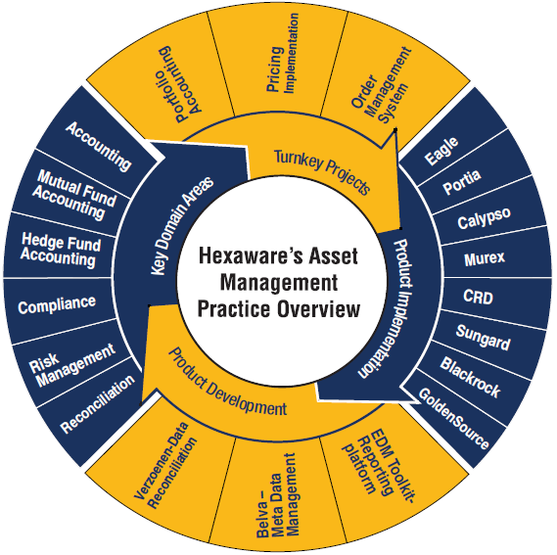

Hexaware has expertise across all security types including Equity, Fixed Income, Derivatives, Mutual Funds and Cash Instruments in supporting the Front Office, Middle Office and Back Office operations.

Hexaware provides solutions in the following areas:

* Reference Data Management
* Market Data Solutions
* Portfolio Accounting
* Settlement Confirmation
* Wealth Management
* Client Reporting
* Performance Measurement Attribution
* Compliance
* Fund Accounting
* Billing Management
* Risk Management

Some of the primary work performed for Asset Managers includes:

* **Consulting:**
  + Product Selection, Platform Consolidation, Portfolio Rationalization, Advisory, Reengineering, Modernization, IT Road Map and Governance to modernize existing legacy solutions
* **Application Development and Management:** 
  + Application Architecture and Design, Migration, Integration and Application Support, Maintenance for Proprietary and Third Party Systems
* **Third Party Products Implementation, Customization & 24 X 7 Global Support:** 
  + Eagle, Calypso, Portia, Charles River, Bloomberg POMS, Murex, Summit, others
* **Reporting and Data warehousing Services:** 
  + Eagle, Cognos, Actuate, Business Objects, Micro Strategy and Informatica
* **Electronic Trading Solutions:** 
  + FIX, FXML, STP, Exchange Interface, Reference Data Management, Market Data Management, DMA, Order Routing
* **Independent Testing Services:** 
  + For Front office, Middle Office and Back Office using Rational and Mercury suite of products/tools

**Capital Market Solution**

The business areas covered under the various domains are as follows:

* **Pre-Trade:** 
  + Pre-Trade mainly covers the business areas related to Pricing and Analytics, Static Data and Limit Monitoring.
* **Front Office:** 
  + Front-Office concentrates on Trade Capture, Day count issues, User Access Permissions, Product definition and Trade Details Amendment.
* **Middle Office:** 
  + Middle-Office covers the areas of Risk Management, Position Management and Portfolio Analytics.
* **Back Office:** 
  + Back-Office focuses on Reconciliation, Settlement Issues, Reconciliation Issues, Payment Generations, Confirmation Generations and other related areas.

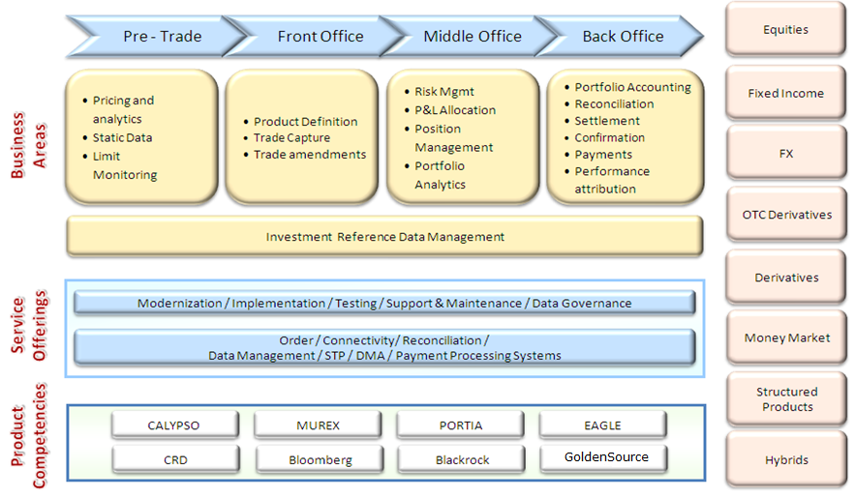

**Key Engagement Snapshot**

|  |  |  |  |
| --- | --- | --- | --- |
| **Client** | **Type Of Engagement** | **# Of Resources** | **Partnership** |
| Global Asset Management Firm | * Application Support, Maintenance and Development of Application Consolidations Initiative, Migration, Data Management, Portfolio Management, Reconciliation and Client Reporting covering various asset classes like Equities, Fixed Income and Derivatives | 75+ | 10+ Years |
| Leading Global Custodian | * 74 applications supported 24*7 (US, Europe and Asia-Pac Region) * Application Support and Maintenance of Front Office, Middle Office and Back Office applications in the IM, ERM, ERP divisions covering various asset classes like Equities, Fixed Income and Derivatives | 285+ | 6+ Years |
| Fortune 500 Asset Manager | * Application Support and Maintenance of Front Office, Middle Office, Back Office and ERP applications | 40+ | 2+ Years |
| Leading Partnership Bank | * Application Support, Maintenance and Development Front Office, Middle Office ,Back Office and Client Reporting applications | 180+ | 6+ Years |
| Leading Canadian Insurance Money Manager | * Application Support, Maintenance and Development Front Office, Wealth Management and CRM applications * 24/7 support of Back Office Accounting system | 40+ | 3+ Years |
| Leading Investment Manager | * Back Office Accounting System Operations Support * Eagle PACE Data Warehouse Implementation and Support * EDM ODS Application Support * EDM Consulting and downstream implementation * Development of Index Platform Consolidation | 140+ | 5+ Years |

## Hexaware’s (Distributed, Multi-Tier and J2EE) Technology Capabilities

**Legacy Internet and Hexaware Focus**

Organizations which have implemented e-solutions adopting first generation internet technologies such as CGI/Perl, VBScript/ASP, HTML/JavaScript, Applets/Servlets (Scripting techniques) face major challenges in providing 24X7 service, seamless integration with back-end enterprise systems, scalability, performance optimization through load balancing, fault tolerance etc. This becomes all the more critical when there is wide customer reach, unexpected increase in number of users and the need of on-line integration with back-end systems. Number of B2B and B2C applications developed in the mid-nineties need major technical enhancements & reforms to provide scalability.

Hexaware has specialized in providing scalable architectural services especially using BEA WebLogic, IBM WebSphere & EJB platforms (Using the industry standard J2EE compliance). In addition to this, Hexaware is also focusing on IONA products like ORBIX, Microsoft .Net to increase its service offerings in heterogeneous distributed environment using CORBA, J2EE/Application servers and .Net based application development to remain competitive in this market space. The live experience of Hexaware in n-tier architecture applications development is re-engineering of over 5 million lines of mainframe application code into n-tier architecture supported by J2EE platform and application servers like Web Sphere, Web Logic on SUN Solaris, Oracle platform integrated to mainframe enterprise databases systems in IMS and CICS environment using MQ series messaging services.

**Technology Partnerships and Methodology**

* Business partner with IBM and "Star partner" with BEA Systems.
* Strong project experience including all the WebSphere product range such as WebSphere commerce suite, application server, transcoding server, etc.

Proven experience in re-engineering of large mainframe (COBOL, PL/I, FOCUS.) applications (in Insurance industry) into J2EE platform with n-tier architecture supported by Application server BEA Web Logic, Oracle DBMS on Sun Solaris platform with MQ series based integration with co-existing m/f applications. On development methodologies Hexaware is using the combination of SEI MM Level 5 processes and emerging software development methodology (Rational Rose based (RUP) resulting in high level of automation of Object-Oriented Design, leading to high quality, re-useable components which is the strategic direction of many organizations in the component based development environment.

**J2EE Compliant technology Experience**

Hexaware has extensive experience in J2EE compliant technology/standards and takes full advantage of the J2EE platform and technologies for building component based, scalable and robust business applications. Hexaware uses beans for system components, Java Naming and Directory Interface (JNDI) to address user and group management, Java Database Connectivity (JDBC) to interact with the server database, Java Message Service (JMS) to enable inter-object communication, Java Server Pages (JSP) for user interface creation, and the Java Servlet API to integrate the system with a Web server.

**Hexaware’s Service Offerings**

Hexaware provides several services in the J2EE area both within the organization and for its valued customers. The JEE CoE within the organization acts as the mentor-in-chief for all technology initiatives at Hexaware. This ensures that knowledge spanning multiple verticals and geographies is centrally managed. The CoE adopts a component based development approach which provides reusable IP; it has developed a proprietary, home-built tool set called the Hex Studio 3.0, which is a suite of ready-to-use reusable components providing a head start in delivering various services based on open source technologies. The CoE is also home to a large, talented resource pool of developers, technical specialists and architects proficient on various J2EE technologies and certified in multiple platforms including Sun, IBM and BEA. The following diagram illustrates the Hexaware’s J2EE offerings in a nutshell:

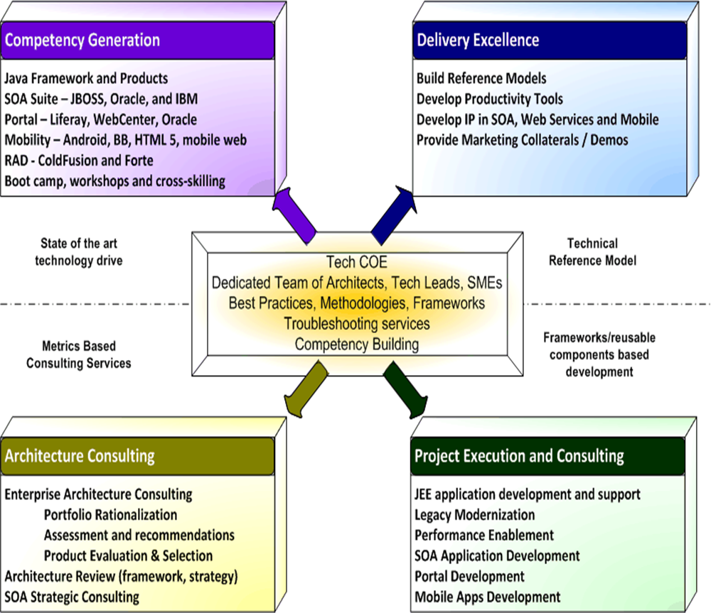

**Hexcelerator Framework**

This is an in-house framework developed by Hexaware to jumpstart development in J2EE projects. It is part of Hexaware’s Enterprise Continuum and is the repository of all java-based technical re-usable assets within Hexaware.

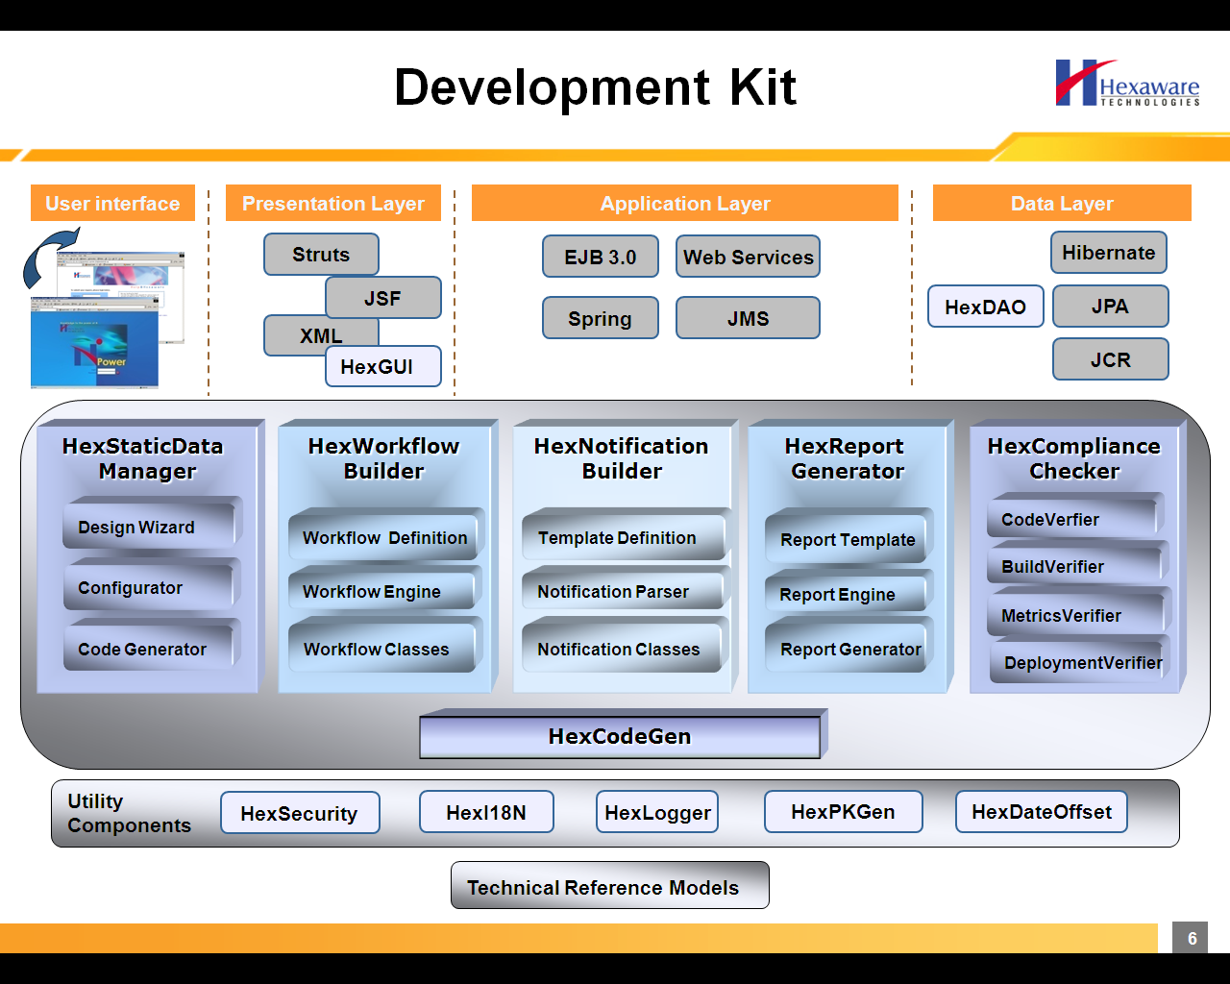

Benefits of this framework include:-

* Facilitates effective end-to-end architecture consultancy
* Helps to improve quality, development effectiveness and maintainability
* Provides access to critical reusable components to reduce defects
* Enables to focus on core business
* Guaranteed improvement in the development time

**SOA Competency Offerings**

In addition to standard J2EE offerings, the Java CoE of Hexaware also provides solutions in the SOA arena as well. Hexaware has proved its capabilities by developing the following SOA-based applications in both Java (IBM Websphere & BEA Aqualogic suites) and Microsoft (.NET 3.0) platforms:-

* Loyalty Program for the TTHL (Transport) domain using BEA Aqualogic platform
* Re-usable web services in the Work Order Domain implemented in Microsoft .NET, which were then consumed and enhanced through applications developed on all three SOA suites – BEA Aqualogic, IBM WebSphere and Oracle
* Reference Implementation for Auto Insurance Claims domain using IBM Websphere family, including IBM Business Process Modeler

Hexaware has acquired a high degree of expertise in developing applications using the following SOA suites available in the market:-

|  |  |  |
| --- | --- | --- |
| IBM Websphere Suite (v6.x) | BEA Aqualogic Suite | Oracle SOA Suite (10g) |
| Business Modeler | ALSB v2.5 | BPEL Process Manager |
| Integration Developer | AL BPM v2.7 | Web Services Manager |
| Process Server | WebLogic v9.2 | Enterprise Service Bus |

**Hexaware’s Application Server Practice Focus**

Hexaware addresses the challenge facing enterprises in developing scalable e-commerce applications using application servers to run their e-business. Hexaware’s e-solutions framework is based on high-end, high performance, open and scalable architecture using the market leading application servers BEA WebLogic Server and IBM WebSphere Application Server.

Hexaware’s Application server practice focuses in building the competence in BEA WebLogic Application server and IBM WebSphere Application server and providing scalable enterprise solutions using these servers with compliance to J2EE standards and specifications. In addition to these application servers, there is a constant market watch to recognize the emerging products in the app server arena, which helps in planning competency building in those areas too.

**Front End capabilities**

Hexaware has also developed complimentary capability in front end technology like JAVA. This has given us capability to develop complete portals for many customers.

**Services offered**

The various customized e-solutions offered by this practice are:-

* Strategizing and planning for e-commerce initiatives
* Architecting & developing e-Applications (B2C / B2B).
* Re-engineering legacy systems to Web platforms.
* Migrating internet applications to scaleable n-tier Application Server architecture.
* Work-flow Automation & Intranet solutions.
* Portal development.
* Web Maintenance.
* Wireless / mobile enabling using WAP, Palm, SMS technologies.

**Technical Capabilities**

|  |  |
| --- | --- |
| Area | Tools / Technologies |
| Middleware | XML, EJB, COM/DCOM, CORBA |
| Application Servers | BEA WebLogic, IBM WebSphere |
| Web Servers | Apache, Java webserver, iPlanet webserver, Lotus Domino web server |
| Security | SSL, SET,LDAP |
| IDE | Visual Age for Java, Symantec Visual Café, ,jBuilder |
| Case Tools | Rational Rose 2000, RUP |
| Testing Tools | Compuware QA Run, QA Load, |
| Database Servers | SQL Server, Oracle 8I, DB2 |
| Frameworks | Decelerator v4.0, Spring, Struts, JSF |

## Quality Assurance and Testing Services (QATS) Capabilities

Quality Assurance and Testing Services (QATS), Hexaware’s Independent testing unit, is aimed at enhancing, optimizing and developing your testing processes with the purpose of driving more business benefits from your Quality Assurance. More than 40 Fortune 500 customers and over 80 Forbes Global 2000 customers spread across diverse industry segments have leveraged our best practices, immense industry knowledge, reusable assets and comprehensive test repository to increase productivity, accelerate time to market and reduce costs. We effectively use the Approach, People and Technology (APT) methodology for better performance and enhanced customer satisfaction.

**QATS Philosophy**

Our QATS philosophy rests on a solid framework of industry best practices characterized by effective strategy, defined processes, proper execution and effective governance. The testing roadmap traverses four stages which amalgamates domain expertise with clear process guidelines to meet defined objectives.

**QATS Offering**

Hexaware’s testing service offerings are aimed at providing the cutting edge solutions to our customers in terms of time-to-market, robustness, quality and cost effectiveness. Our client engagement roadmap is enhanced by consistent value addition facilitated by the fusion of strategy, process and governance.

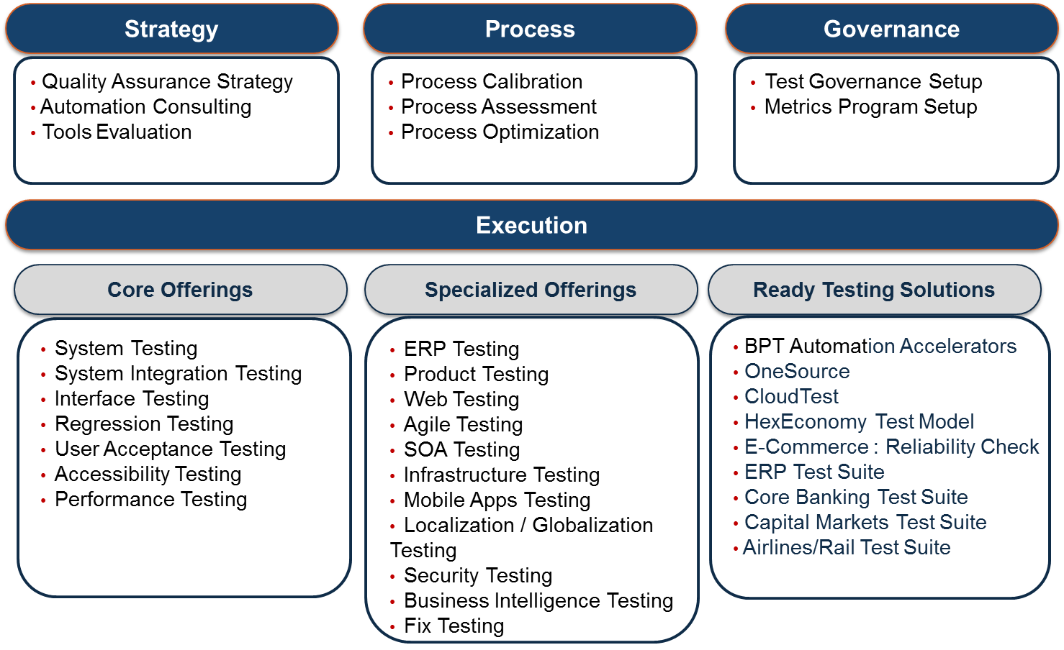

**QATS Snapshot**

* Dedicated Testing Center of Excellence
* Core focus on Industry Domain and Technology based testing
* Ready-to-use Innovative Solutions and Frameworks
* Domain Leadership
  + Banking, Financial Services and Insurance
  + Asset Management & Capital Markets
  + Travel and Transportation
  + Healthcare & Life Sciences
  + Manufacturing
  + ERP
* Over 1000+ Test Professionals
* 70% are Certified Test Professionals (ISTQB / ISEB / CSQA / CSTE / HP / CSM)
* Expertise in various testing tools - HP, IBM, Microsoft, OpenSource, etc
* Strategic alliances with HP, IBM, ORACLE, SOASTA, Jamo Solutions, Greenline and Validata
* Over 350+ Quality Assurance & Testing engagements
* Over 150+ ongoing engagements
* Global Delivery Model with 365 x 24 x 7 support
* Dedicated Automation and Performance Center of Excellence (CoE)
* Mobile Testing (CoE)
* Performance and Accelerators

|  |  |  |  |
| --- | --- | --- | --- |
| **Strategy** | **Process** | **Execution** | **Governance** |
| * Translate Vision to Road-Map * Strategize QA * Plan QA optimization * Align Process, Execution and Governance towards * Vision | * Align with TPI/TMM Maturity Models * Define / Harmonize Process * Paradigm Shift to Defect Prevention * Define-Refine-Optimize | * End-to-End Managed Services * Flexible Delivery/Engagement Models * Lower Total Cost of Ownership | * Visibility on Application Status * QA Portfolio Management * Define Strategic, Tactical & Operational level metrics * SLA based Governance |

**QATS Benefits**

Dedicated Testing Centers of Excellence coupled with core focus on Domain and Technology Consulting guarantees the following business benefits.

* Reduction in production defects by 80% with more than 99% test effectiveness
* Major reduction in testing cycle time
* Productivity improvements of over 70%
* Faster time to market
* Guaranteed reduction of operation cost

**QATS Innovations**

Considering the need for continuous improvement and constant cost reduction, Hexaware has been investing on new innovative solutions in Domain, Technology, Product and Process. QATS accelerators ensure utmost quality, improves productivity and reduces overall testing cost.

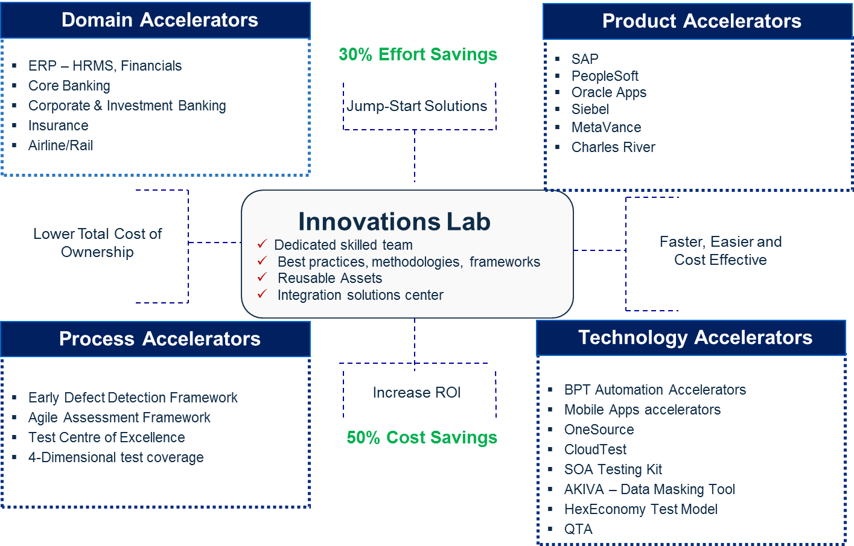

# Locations

Hexaware Technologies (www.hexaware.com) is a leading IT and BPO services provider**, listed among the Top 20 Indian global IT services organizations.** Founded in 1992, we are a **US$ 308 Million** company with **presence in 32 locations worldwide**. Hexaware currently maintains seven **state-of-the-art development centers - Five in India (Mumbai, Chennai, Pune, Nagpur and Bangalore), one each in New Jersey and Mexico**.

With over 500 Fortune/ Global clients, the need to ‘reach out’ is eminent. Hexaware has realized this business need and has suitably **spread across 31 locations worldwide to support 194 clients in 25 countries.** The scope of Hexaware across the globe is suitably illustrated in the figure below.



In terms of technology infrastructure, Hexaware is making optimum investments in latest technology to enhance services for customers. Further rationalization would continue during the road ahead. The following are the updates at its different facilities:

**Mumbai:** Hexaware has two offshore development centers at Millennium Business Park, Mahape, Navi Mumbai, one of them being Registered Office of the Company. Hexaware’s wholly owned subsidiary Caliber Point Business Solutions Limited also owns another building in the same complex, providing BPO services.

**Chennai:** The first phase of the Chennai Green Campus is operational and about 3,000 professionals work in this state-of-the-art facility. This 27 acre environment friendly and world-class facility, when fully functional would seat approximately 5,000 software professionals.

During the year 2011, Hexaware had set-up several dedicated offshore development centers (ODC) within the Chennai SEZ for several of its key clients. Through these dedicated ODC’s, the clients are offered secure and very exclusive work areas with customized access control, CCTV coverage and a world – class work environment.

Hexaware also has an offshore development Centre, Hexaware Towers I at GN Chetty Road, Chennai. Caliber Point Business Solutions Limited also owns another building in Chennai providing BPO services.

**Nagpur:** Hexaware and Caliber Point have together acquired 20 acres of land in Nagpur, a tier II city, at a SEZ location. A 1,000 seat facility is ready and the campus can be scaled up further to accommodate 3,000 people through multiple phases. As of December 2009, Caliber Point has occupied 300 seats at the SEZ facility.

**Pune:** Hexaware has consolidated its operations into a 37,892 square feet building at Pune to accommodate 500 Software Professionals.

Additionally, Hexaware has acquired 97,010sq.metres of land at the Rajiv Gandhi InfoTech Park in Hinjewadi SEZ.

**New Jersey (USA):** Hexaware has established a Global Delivery Centre (GDC) at Secaucus, New Jersey (USA) to cater specifically to its North American clients. While this proximity Centre offers benefits such as the similar time-zone, timely communication and enables convenient management control, it also enables the clients to outsource mission-critical tasks and share secure information. In the current economic scenario, Hexaware believes that North America based clients are likely to be more receptive towards the North America based Global Delivery Centers.

**Saltillo (Mexico):** Hexaware has a strong presence in Mexico where Hexaware has set up a near-shore Global Delivery Center. While Mexico offers cost – competitiveness compared to the United States of America, the country also provides immense benefits in the form of same time zone, enables immediate response and access to a vast talent pool and an untapped emerging market. Hexaware has consolidated the operations of the wholly owned subsidiary Focus Frame and Hexaware’s own delivery Centre into one single facility at Saltillo. Hexaware intends to leverage its near shore Global Delivery Centre to cater to several global clients.

**Note-**Access security details have been included in InfoSec Questionnaire document.

# Recruiting & Retention

Recruitment is one of the most vital functions at Hexaware. The activities are carried out in a phased manner and consists of two streams

* Planned Recruitment
* Need Based Recruitment

**Highlights of the recruitment strategy at Hexaware**

Each business unit has a dedicated in-house recruitment resource to fulfill the manpower requirements for that particular unit

The recruitment resource maintains a skill sets database based on experience and previous employment history, which helps him / her to react immediately, whenever there is a need for resources

Sharing of resource requirement information across Business Divisions and use of the PeopleSoft Recruitment Module enables quicker turnaround and time to recruit

## Eligibility of Candidates

The minimum criteria for any candidate to qualify for an interview will be as per the following grid. This grid will be applicable to all candidates upto 5 years of experience. Candidates with more than 5 years of experience will be screened based on experience and competency.

|  |  |  |
| --- | --- | --- |
| **Qualification** | **Min Percentage** | **Min Post Qualification Exp (in yrs)** |
| BE, B. Tech, MCA, B Sc ( Tech ), | 60% | 2 |
| ME, M Tech, MBA(FT) | 60% | 2 |
| B Sc, M Sc | 60% | 4 |
| Ph D | NA | 1 |
| D Sc | NA | 1 |
| AMIE | 65% | 4 |
| BA, MA, B Com, M Com | 60% | 5 |

Any deviation will require prior approval from the Global Head of Recruitment (GRH) and the total number of deviations cannot exceed 10% of the total hires in each location in a year. Deviations may be based on skills availability.

Please note that any part time degree at the graduate level will not be considered as a qualification for eligibility. Candidates with full time graduate degree and part time master’s degree will need to secure a min of 65% throughout their academic career ( beginning from Xth Std to the highest degree ) to qualify for an interview in Hexaware.

## Planned Recruitment

Planned recruitment is carried out on the basis of the overall business plan of the Organization. This activity is planned on a quarterly basis.

* The Business Unit Head generates the request for requirement of resources, either for project or for practice, based on the requirement and business plan for the unit
* The requirement forms the input to the PeopleSoft Recruitment Module, which in turn is forwarded to the Resource Management Group for approval
* Upon approval from the Resource Management Group, the recruitment team carries out the process of identification of the required skill set through various channels
* The recruitment team plans the total number of resources to be hired through the respective channels taking cost and quality factors into consideration
* Service levels laid down by the Human Resource Group for planned recruitment is to fulfil the request within 45 days from the date of request by the Business Unit Head



The resources are hired through the following channels:

* Advertisements
* In-house Resume Database
* Job site subscriptions
* Recruitment Agencies
* Employee Referrals
* Campus Interviews from Engineering and Business Schools
* Website
* Job fairs

## Time bound process for Need Based Recruitment

The requirement of resources could be need based or could be an immediate requirement for a project. Such requests are given high priority and the process is completed at a shorter duration than the defined service level.

## Recruitment of new entrants

Short listed candidates are called for an Interview. The selection process followed will depend on the experience of the candidates. An applicant might be allowed to skip certain phases of the selection process depending on his experience and other factors.

|  |  |
| --- | --- |
| **Fresher** | Aptitude test, Group Discussion, Technical & HR interview |
| **< 3 years’ experience** | Technical test, HR personality & attitude interview, Two rounds of technical interview followed by a discussion with HR |
| **>3 years’ experience** | HR personality & attitude interview, Two rounds of technical interview followed by a discussion with HR |

* An interview panel constitutes a minimum of 2 technical panel members and one HR Member.
* Interviewers not less than Project Manager level from Business Units and Manager level from HR/other groups
* In case of non-technical Interviews, the panel will consist of one member from the respective group, one HR member and one member from Delivery Unit at the level of Project Manager or above

The flow of activities is shown below:

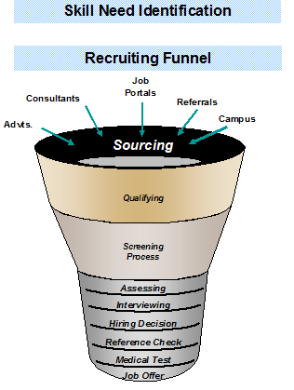

## Onsite Recruitment Process

Reasons why we might have to do an onsite hiring are

* One time effort which does not require a dedicated resource
* Rare skill set which needs to be acquired from the local resource pool
* Unavoidable circumstances of unavailability of Hexaware resources

We only do lateral hiring onsite and the three types of hiring we follow are

**Direct Hiring**: - Direct hiring is done by interviewing candidates who approach us through various sources like internal references, job portals, corporate image etc.

**Contract hiring**: - We have entered into Independent Contractor Agreement, 1099 with contractors in US who provide us with Contract employees for specific assignments.

**Corporation to corporation hiring:** - We also maintain relationships with other IT service providers and loan resources from other corporations for urgent requirements.

The process includes

* Hexaware interviews - The employees are interviewed by our team. Either onsite team or the offshore resources are used for the interview
* Client interviews - The client can interview the resource before they are employed.

## Resource allocations and management

At Hexaware we pay a lot of importance to find the right people for the right job. We are very selective in identifying people and allocating them to a particular client project. We have adopted the following process to ensure the right resource get assigned to the project:

* RMG (Resource Management Group) maintains a database of skills that each Hexaware employee possesses.
* For each project that is about to begin RMG maps the skill sets that the project would need with the candidates who have that relevant skills expertise, in their database.
* RMG looks at getting the best fitment possible through the release of resources from existing projects and internal bench. Since most of the projects have phase-wise ramp up, RMG also looks at future releases in next one quarter so that the resources can be mapped.  By this the next assignment for the resources is identified well before they are released from their current projects.
* The person identified then undergoes internal selection interview where the PM interviews him and on a case to case basis gets interviewed by the client, before being allocated to the project.
* In case, if a decent match of the required skill-set is not available internally, then the same (required resource skills) would be identified and passed on to the Hexavarsity team, who then will prepare a training plan to fill the gap between existing vs. desired skill-sets so as to deploy the resource in the project. This way we ensure that we have a continuous improvement program in place whereby our resources are re-skilled / Cross skilled adequately to address client needs.

If RMG is unable to suffice the desired skill-set from the internal bench, release plan or cross skilling, it is passed on to the Hexaware Recruitment team (HRT) who in turn will source the resources from recruitment portals/external pre-approved vendors to fulfill the requirement. We have a 2-Tier approach where we ensure the person being hired is the best-fit for the job which often is substantiated by the client interviewing the candidate and giving him/her the final nod.

# Screening

**Screening of Recruitment agencies**

The in-house recruitment resources screen and rank the agency that provides resources. Hexaware then liaises with the agencies that provide quality and satisfactory resources.

**Screening of New Recruits**

Some of the measures taken by HRG include:

* Reference checks with the previous employer
* Review of proof of experience and educational status: Prospective candidates are required to produce documents / information relevant to their candidature (all original certificates and mark sheets in proof of their educational qualifications, experience certificates and relieving letters from all the previous employers)
* Medical Check: Prospective employees are also required to undergo a pre-employment medical check-up in the Hospital authorized by the Organization.
* Criminal background check: Verification of passport as a check for any criminal record, use of external agencies for criminal background check



# Quality & Project Management

## Project Management

Hexaware’s Engagement project management model takes a holistic approach to manage large projects. Hexaware tracks the engagement at various levels to ensure that all aspects of the engagement including project delivery, infrastructure, quality processes, resource management and financial issues are addressed. Hexaware manages a typical engagement through the following well defined process.

|  |  |
| --- | --- |
| **Process** | **Activities** |
| Policy | Model, Methodology and Service Level Definition |
| Ability | Infrastructure Setup, Training, Team Potential & enhance team skill level |
| Activity | Evolve Operational Manual defining all activities |
| Verification | Project Reporting and Project Reviews |
| Audits | Client Inspections, Client Reviews, Internal Audits and External Audits |
| Metrics | Project Metrics, Process Metrics and Analysis |

Hexaware would adopt application development methodology to execute the projects. The organization structure for executing the project will consist of the Delivery Manager, Account Manager, Project Director, Project Manager, Project Leads and Domain and Technical team from Hexaware. These individuals would work in coordination with members of client and share responsibility for the development, execution and dissemination of various processes, tasks, standards and deliverables.

Hexaware has implemented an enterprise wide project management tool called “**Plan Arena**” which covers end-to-end project management process viz. project planning, tracking, risk management, defect and SLA management.

**Project Management Processes**

Project management processes that are critical for large-scale project execution is outlined in this section. An overview of the project management process is depicted in the following diagram.

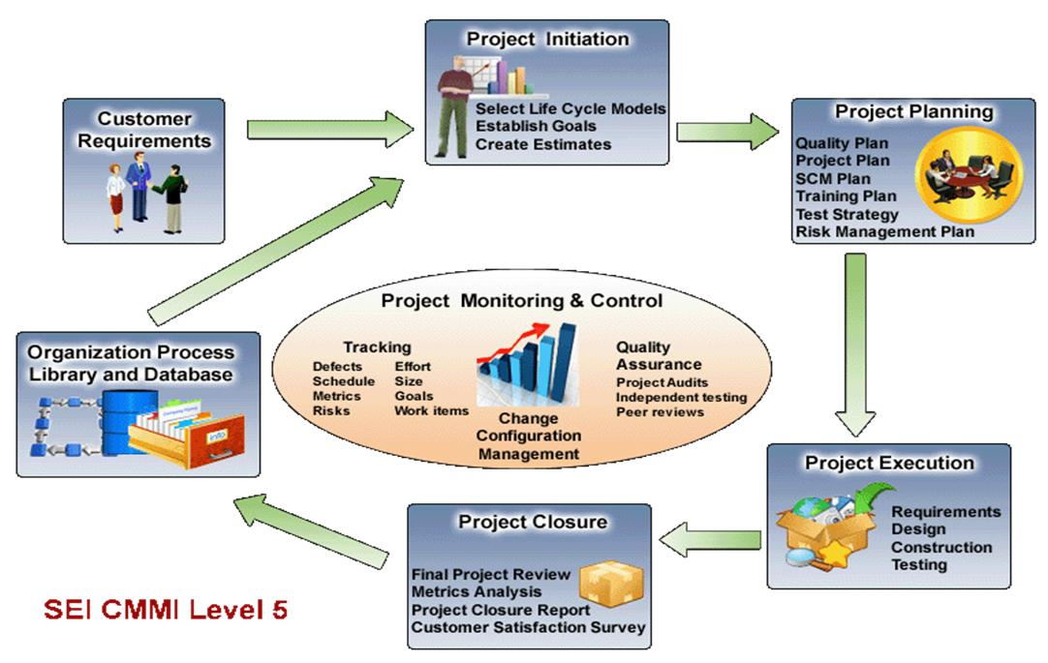

**Project Planning**

Project planning is initiated once the proposal is agreed upon and signed. Projects may use organization process to suit the project specific requirements or tailor the same and accordingly a life cycle model is defined. Detailed Project Plans are prepared and maintained for every project by the Project Managers. These plans are comprehensive and cover all aspects of the project – Objective and Scope, Roles and Responsibilities, Dependencies, Assumptions, Customer Requirements, Methodology, Team Structure, Communication, Deliverables, Project Phases Schedule and Milestones, Internal Project Deliverables, Resources, Tools and Techniques, Problem Reporting and Corrective action etc. Other planning documents include detailed Quality Plan, Contingency Plan, Training plan & Configuration Management Plan.

The Project Plan forms the basis for all project management activities and is revised as and when applicable. Detailed schedules are drawn up using MS Project and actual progress of various activities is tracked against the plan throughout the life span of the project.

**Project Monitoring & Control**

Hexaware has well established project management tracking methodologies and processes assessed at CMM level 5. Hexaware relies heavily on the usage of data and analyses of metrics from projects.

The implemented tool will assist in establishing a more rigorous control in the area of Project Planning and Monitoring and has the following major modules:

* Project Planning – using the tools native features and also seamless integration with MS-Project.
* Task Assignment – task assignment to project resources which can be seen in the inbox of the team member
* Time sheet entry and task update – time booking against the task and status update
* Defect / Issues and Action Items monitoring
* Assignment of defects to team members for fixing and closing of these
* Rich query and reporting features which gives insight into the status of projects

Project control is achieved through reviews, checks and controls at every stage of the project. Management and technical reviews and status reporting are an integral part of project execution.

Project reviews are conducted periodically (normally every week) with the project teams. These reviews address both project management and technical aspects of the project. Schedule, effort, Change management, review and test defects, planning and monitoring are typically reviewed.

Internal Senior Management reviews of the project are conducted periodically (minimum once a month and at completion of milestones) to ensure that the project is on track and also to address any outstanding issues that are escalated to the senior management.

Joint reviews with the customer are carried out at least once a month, or more, depending on the customer requirement and duration of the project. Technical clarifications required, conformance of the software to agreed requirements; schedule & deliverables, project progress etc. are reviewed.

Technical Reviews / Walkthroughs are conducted for all technical work products to ensure good quality of the deliverables and also to ensure that customer requirements are being met.

Periodic status reports with details of project progress, project overall status, major issues, risk status etc. is sent periodically to the customer and senior management.

High-risk modules are identified at the start of the project and tracked, critical incidents logged and analyzed and corrective action taken to ensure that risks are minimized.

Information security controls and business continuity planning need to be addressed by the project during project execution. The project also needs to address client specific security, confidentiality and non-disclosure requirements. All information security management activities are audited as part of the information security audits.

**Change Management**

Changes to software requirements are achieved through documented Change Management procedures. Procedures for recording the change requests, conducting impact analysis and recording the results of this analysis, and approval mechanisms are clearly documented.

Execution of the changes is controlled by prioritizing the requests, monitoring the progress of the changes.

The impact of the Change can be classified into these broad categories:

**Impact of Change on Cost:** For any CR in a large-scale engagement, Hexaware uses a pricing model based on estimated Full Time Employee (FTE) count and the onsite-offsite resource ratio. Any changes in the application mix might impact the parameters used in the pricing model. If the cost impact is substantial, Hexaware will submit a revised price. If the applications mix results in a lower cost in the pricing model, the same shall be passed on to the client. If the changed application mix causes any part of the execution model to be modified, the same will be done with sufficient communication and understanding between the client and Hexaware.

**Impact of Change on Schedule:** Changes to the requirements may also entail work schedule changes. In cases where project schedule changes impact business performance, Hexaware can quickly ramp up the project team with appropriately skilled resources from the pool. However, if the nature or amount of change is such that the schedule change cannot be avoided, the same would be done after mutual agreement with the IRAS.

**Plan Arena:** Hexaware has developed an enterprise wide project management tool called **“Plan Arena”** which covers end-to-end project management process viz. project planning, tracking, risk management, defect and SLA management.

The implemented tool will assist in establishing a more rigorous control in the areas of Project Planning and Monitoring. It has the following major modules:

* Project Planning –the tool’s native features and also seamless integration with MS-Project would be used for project planning.
* Task Assignment – Task assignment to project resources which can be seen in the inbox of the team member
* Time sheet entry and task update – Time booking against the task and status update
* Defect / Issues and Action Items monitoring: Assignment of defects to team members to fix and close
* Rich query and reporting features: Gives insight into the status of projects
* Consolidation of projects and status at various levels
* Visual dashboards – For various roles
* Customer dashboard – This would provide visibility to Client on project progress on an almost real time basis
* Knowledge repository
* With the implementation of this tool Hexaware will achieve:
* Data integrity across all projects
* Transparency in project progress
* Exceptional reporting which would help in taking timely corrective actions

Through Plan Arena we are able to generate the below stated benefits that help both Hexaware and the client in smooth operation of the project.

**E-Dashboard**

* Provides visual representation of critical operating parameters in the form of e-Dashboards
* Graphical representation of critical operating parameters
* Rolled up data that can be drilled down
* Personalized dashboards for different roles i.e. CXO, Customer, SEPG, Project Manager, Developer, Resource Manager, etc.

|  |  |
| --- | --- |
| **Plan Arena** | **E-Dashboard** |
|  |  |
| **Projects and Timesheet** | **Resources** |
| * Plan project as per QMS standards and Customer expectations * Two-way Seamless Integration with Microsoft Project * Prepare Project Management Plan and keep it live all the time * Work allocation to project team members * Track resource movements * Execute, Track projects using Project Timesheet and Task Completions * Collect and process organization and SLA measurements * Reports on Project Progress and Earned Values * Helps with quality process compliance | * Tracks the time, effort and skill sets of the resources * Maintain inventory of skills, experience for all resources * Powerful reports for resource availability and allocation * Resource Loading and Capacity Planning * Resource Utilization and Billability Ratios |
| **Defects / Action Items / Issues** | **Timesheet & Expenses** |
| * Standardized Engineering Defect and Issue types for organization * Captures issues over the web, in real time at the point of their detection * Alert, Assign, Work and Report to close the loop. * Real time issue status available to all stakeholders, along with Discussion Threads. * Analyse issues / defects for project / across projects for root cause using effective issue based reports * Captures and tracks metrics on corporate and project levels | * Can track activity based as well as task based timesheets * Resource can request for additional time to complete tasks (ETC Request) * Capture Rework and CoQ related information (Implicit) * Captures time for overhead activities * Captures expenses incurred on Project * Three different modes of timesheet entry * Resource Timesheet approval process * Principle of ‘Enter Once Report Everywhere’ |
| **Help Desk** | **Knowledge Management** |
| * Generic tool to satisfy the support requirements of Customers * Assign requests and track them through their resolution, along with Discussion Threads | * Institutionalize Knowledge * Disseminate and Share accumulated knowledge with all the Stakeholders * Enhanced Search and Authentication Features |
| **Processes** | **Reports-Metrics** |
| * Organization Quality Parameters Definition * Organization Quality System Definition * Organization Measurement System Definition * Standardizing Implementation Practices * Milestone & Project Closure Analysis Processes * Manage Organization Process Capability Baselines | * Flexible tool to extract and present Critical Enterprise wide Information * Custom Reports: Build Your Own Reports * Query Builder: Separate the Technical Details and Create Reports using User Friendly Terminology * SLA Tracking |

## Quality @ Hexaware

Hexaware has a well-defined Quality Management system, which addresses all management and technical processes through all the life cycle phases of project execution. The scope of the Quality Management System (QMS) encompasses the core business activities of software development and software project management and conforms to international standards (ISO, CMM & Six Sigma).

Hexaware has a comprehensive quality model carefully built around the framework of Total Customer Experience (TCE). Hexaware is committed to quality and our development centers are assessed at SEI CMMI Level 5.

### QA Architecture: The diagram below shows the QA architecture at Hexaware

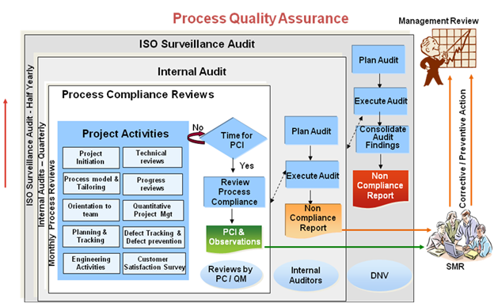

|  |  |
| --- | --- |
| **PCI** | **Process Compliance Index** |
| **SQA** | **Software Quality Assurance** |
| **PMR** | **Project Management review** |

QA at Hexaware is achieved through internal quality audits, work product inspections, independent testing and reviews. Product and process quality is ensured through:

* Internal Quality Audits
* Structured facilitation
* Peer reviews and independent unit testing of work products
* Work product inspections prior to delivery
* External Quality audits

### Internal Quality Audits

Internal Quality System Audits verify that activities are carried out in accordance with the Quality Management System (QMS), and that the QMS continues to meet the needs of the business and the requirements of process improvement models/frameworks. Effective audits by Competent Auditors are the key to ensuring that QMS remains "alive" and delivers the full benefits for the Organization.

The main objectives of a Quality System audits @ Hexaware are:

* To ensure that the QMS meets the requirements of recognized quality standards
* To ensure that QMS is understood and followed by everyone
* To meet customers' contractual requirements
* To improve the efficiency & effectiveness of quality system

Audits also provide one of the best means of analyzing QMS to identify opportunities for improvement. The effectiveness of the Internal Auditing system is usually a barometer of how committed the organization is to its QMS. Well-performed audits and rapid response to deficiencies generally indicates an effective and widely respected QMS that is actively working to improve business performance.

The Software Engineering Process Group (SEPG) is responsible for carrying out internal quality audits for all projects and support groups. One member of the SEPG Team will play the role of Audit Manager for steering this activity across all locations in India.

### Activities

Internal quality audits are carried out for all projects and support groups on a monthly schedule Each project / support group will be audited at least once in a quarter.

Internal quality audits comprises of the 3 core activities as given below:

* IQA Planning
* Conducting Audits
* Audit Reporting, NC Closure and Audit Analysis

### Structured facilitation

A member of the quality assurance group is assigned as quality facilitator at the start of the project to assist the project in defining and implementing the processes. One member of the project team is identified as the quality coordinator for the project to monitor process implementation during the course of the project.

The quality facilitator conducts an exhaustive process check using a Process Compliance Index (PCI) checklist, which covers various sections such as contract, project initiation, planning, tracking, SCM, Change management, delivery, SDLC and project closure.  Activity specific checklists are used for audit of support groups. The PCI checklist has a mechanism for measuring the process compliance. This ensures consistency in the PCIs and clarity on the processes to be followed. Projects are encouraged to use this checklist for their internal checks also. This checklist is regularly revised based on the feedback from the practitioners.

### Independent Unit Testing & Peer reviews

All software code undergoes independent unit testing using the Unit Test Plans. Test Results are documented and defects found during testing are recorded in the Defect Log and tracked to closure. All work products undergo either peer review or formal technical review. The work products include amongst others proposal, contract, customer requirement specification, request for service (RFS), functional specification (FS), project plans, Test Strategy, design documents (DD), program specification, unit test plan (UTP), integration test plan (ITP), program code, components/beans, installation guides, user manuals.

Project specific standards are prepared at the start of the project and project team members oriented on these standards. Detailed project specific checklists are prepared and used for code walk through and reviews. Where the customer specified standards need to be followed, they are incorporated into the checklists. Review comments are recorded in the Technical Review Report and tracked to closure.  Training on reviews is provided to project team members to help them perform reviews effectively.

Defects found during independent testing and peer reviews are analyzed for severity, cause and attribution and corrective action is taken as necessary. Projects set and track goals for defect density and review efficiency. Projects record effort used in peer reviews and unit testing, number of reviews planned and actual conducted, and number of defects—these are then used for metric analysis.

Projects Peer review/ independent unit testing, Independent Testing & Review Board [ITRB] activities are audited/reviewed/verified during internal quality audit and work product inspection. These activities are checkpoints in the Process Compliance Index checklist and work product inspection checklist.

### Work Product Inspection

Members of the ITRB perform sample testing and work product inspection using a checklist for all customer deliverables before shipment, and the results of the inspection are documented in the Work Product Inspection Report. The ITRB member has the authority to stop shipment of a work product based on the results of the inspection. The Business Unit Head has the authority to override the stop shipment. A recent process change arising from defect prevention activities at the organization level mandates early introduction of ITRB review/testing for the first few work products in every work product type e.g., program specification, code, unit test plan, in order to prevent defects.

### External Quality Audits

Hexaware is an ISO certified organization. External surveillance audits are conducted by the certification agency – KPMG Quality Registrars every six months. Re-certification is carried out once in three years. These assessments give an insight into the organization processes and areas for improvement are identified.

We have various Metrics related to Software Quality such as Defect Density, Post-ship Defect Density, and Review Effectiveness and for testing projects - Test Efficiency, Defect Unearthing efficiency, etc.

The various performance related dashboards that get generated “on-line” from the enterprise wide Project Management Tool Plan Arena provides the overall quality of the service/product. The dashboard screen shot is provided in the enclosed attachment. We also have a DERIVED METRICS that is computed based on selected key metrics in project known as “Project Maturity Index” which is also generated from the enterprise wide project Management tool “Plan Arena”. We use Plana Arena for Defect Tracking, which helps measure the overall quality.

# Team Engagement

Hexaware proposes Hybrid model for the engagement with CME group. This model is preferred in software development outsourcing as the offshore factor results in huge cost savings. Along with this the total cost of ownership of infrastructure and manpower involved is also reduced considerably.

* There will be regular inter team interaction on a daily basis. This will be to address open requirement, technical, testing and migration queries.
* Hexaware Onsite/ Near-shore/Offshore teams will meet on a weekly basis to review status; every Wednesday (can be changed). They will review all work in progress, address pending queries and risks.
* The Project Manager will provide Weekly status reports to CME Project manager on a Weekly basis; every Monday (can be changed).
* On a monthly basis, the Project Manager will provide a monthly dashboard analysis and status report to CME Project manager. This analysis will include the team performance against SLA.
* Forecast of expected resource ramp up or ramp down is also discussed monthly basis.

**A sample communication chart presented below is intended to:**

* To provide a sample of the types of project communication that will occur
* To specify who is responsible for completing the process
* To ensure that it is received by the proper individuals
* To display how the communication is delivered (phone, email, web)
* To display how the communication is presented (document, meeting), and,
* Frequency of occurrence

|  |  |  |  |  |  |
| --- | --- | --- | --- | --- | --- |
| **Communication Type** | **Presented By** | **Presented To** | **How delivered** | **How Presented** | **Frequency** |
| Technical Questions | Hexaware Team | CME Team | E-mail | Word document or email text | As needed |
| Client Status Report | Hexaware PM | CME PM | E-mail | Word document | Weekly, Monday noon |
| Project Status Report | Hexaware PM | Hexaware PD | E-mail | Word document | Weekly, Friday noon |
| Team Status Review Meetings | Hexaware PM, Team | CME PM, team | Meeting / Conf. Call |  | Weekly |
| Status Meeting Minutes | Hexaware PM | CME PM | E-mail | Word document | Day after meeting |
| Planning/Coordination Meetings | Hexaware PM | CME PM | Meeting/Conf. Call |  | As Needed |

Hexaware focuses on building strong transparent communication channels. Joint regular steering meetings ensure overall engagement focus while effectively resolving issues & problems on the way.

Following are some of the regular status reports sent to the client:

|  |  |  |  |
| --- | --- | --- | --- |
| **#** | **Report Name** | **Frequency** | **Purpose** |
| 1. | Status reports | Daily/ Weekly | For recording/tracking the status of project activities with respect to the project plan |
| 2. | Issue Log | Weekly | Better Issue tracking and quicker resolution |
| 3. | Billing reports and Invoice | Monthly | For accurate and transparent invoices |
| 4. | Service Level Agreement | Monthly | Actual Performance standards against the defined SLA |
| 5. | Metrics and dashboards | Monthly | Project specific goals set for the project and the actual performance |
| 6. | Operations Review presentation | Monthly | Monthly Status reporting |
| 7. | Steering committee presentation | Quarterly | Quarterly status reporting of the project along with the issues faced, process improvement activities, resources etc. |

* Management issues, if any, are tracked separately at the unit Head level and closed by him.

**Below mentioned is the responsibility of each level in the project hierarchy**

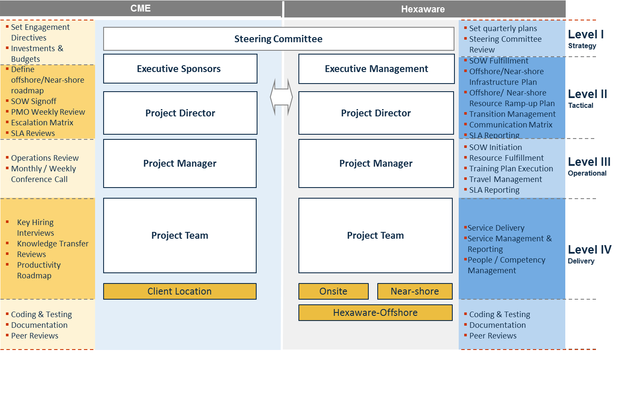

## Escalation Mechanism

We have a well-defined organizational structure and work with a well-defined framework and project structure comprising of a steering committee and account management to take care of any issues.

Communication with the customer involves the following:

* Communication is through email or any mode as agreed to with the customer. All emails sent and received to the customer are tracked to ensure proper responses are sent to the customer
* All clarification raised with the customer are tracked
* All issues raised to the customer are logged and tracked to closure
* The weekly status report is used for recording the status of project activities with respect to the project plan
* Both internal and external escalation details are documented as part of the project plan and followed
* Any complaint received from the customer is logged into the Complaints Log and details recorded in the Complaints Form. The Account Manager / Project Manager ensure that the complaint is closed as per procedures defined.

|  |  |
| --- | --- |
| **Escalation Procedures** | |
| First Level | Project Manager |
| * Provides a single point of contact for day-to-day operational issues in a project * Resolves immediately any operational issues reported and keeps Delivery/Relationship Managers updated | |
| Second Level | Relationship Manager |
| * Provide a single point of contact for day-to-day operational issues * Establish communication protocols with client for issue resolution and reporting needs via e-mail, issue log, encounter reports, etc. | |
| Third Level | Unit Head |
| * Provide support to the project team throughout all project phases * Resolve escalated issues or commit other resources for issue resolution | |
| Final Level | Joint management |
| Joint management of Customer and the Steering Committee of Hexaware. In the event of an issue being escalated to this level, the same is resolved in mutual interest and in line with our philosophy of ‘Partnership’ with the clients. | |

# Rate Card

<<Complete the attached rate card (Exhibit C) for the mentioned job titles. We are interested in seeing rates for each location you offer services in.>>

# Exceptions

<<Describe any exceptions to the requirements in this RFI, InfoSec questionnaire or MCA. List the specific provision to which you are taking exception, the reason for the exception and the impact of the alternative you have included.>>

# Appendix a: Vendor Profile

## Background

Provide a brief history of your company including how many years you have been in business.

Hexaware Technologies ([www.hexaware.com](http://www.hexaware.com)) is a leading IT and BPO services provider, **listed amongst the Top 20 Indian global IT services organizations**.  **Founded in 1992**, we are a **US$ 308** Million company with presence in 32 locations worldwide. Our **client base comprises over 194 organizations**, of which **1/3rd being Fortune 500 companies**. We are a public company listed in India and UK. With employee strength of **8000+**, Hexaware currently maintains seven **state-of-the-art development centers - Five in India (Mumbai, Chennai, Pune, Nagpur and Bangalore), one each in New Jersey and Mexico**.

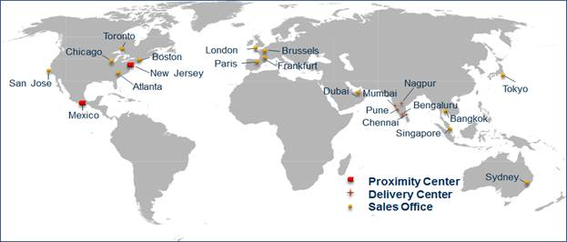

Is your company publicly traded? If yes, since when and at which stock exchange? If no, please provide financial information.

**Financial Stability**

Hexaware is a listed Public Limited Company with its shares being traded on **Bombay Stock Exchange, National Stock Exchange and its Global Depository Receipts (GDR’s) on the London Stock Exchange**.

|  |  |  |  |
| --- | --- | --- | --- |
| **Name of the Exchange** | **Reuters** | **Bloomberg** | **Code** |
| The Stock Exchange, Mumbai | HEXT.BO | APTH.IN | 532129 |
| National Stock Exchange of India Limited | HEXT.NS | NAPTH.IN | HEXAWARE |
| London Stock Exchange | HEXD | | |
| ISIN Demat | INE093A01033 | | |

Some of Hexaware’ financial highlights are:

* Zero Debt Company.
* Cash Positive - Generating Cash Profits consistently, Strategic and value added Investment by GAP.
* Revenues in Q4 2011: **USD 84.1 mn**
* Growth in Q4 2011: **6.7%** sequentially in $ terms
* Profitable and generating cash every quarter

Does your company have alliances with other hardware, software, contractors or service providers? If yes, how could these alliances potentially benefit or limit our options?

**Product Partnerships and Strategic Alliances**

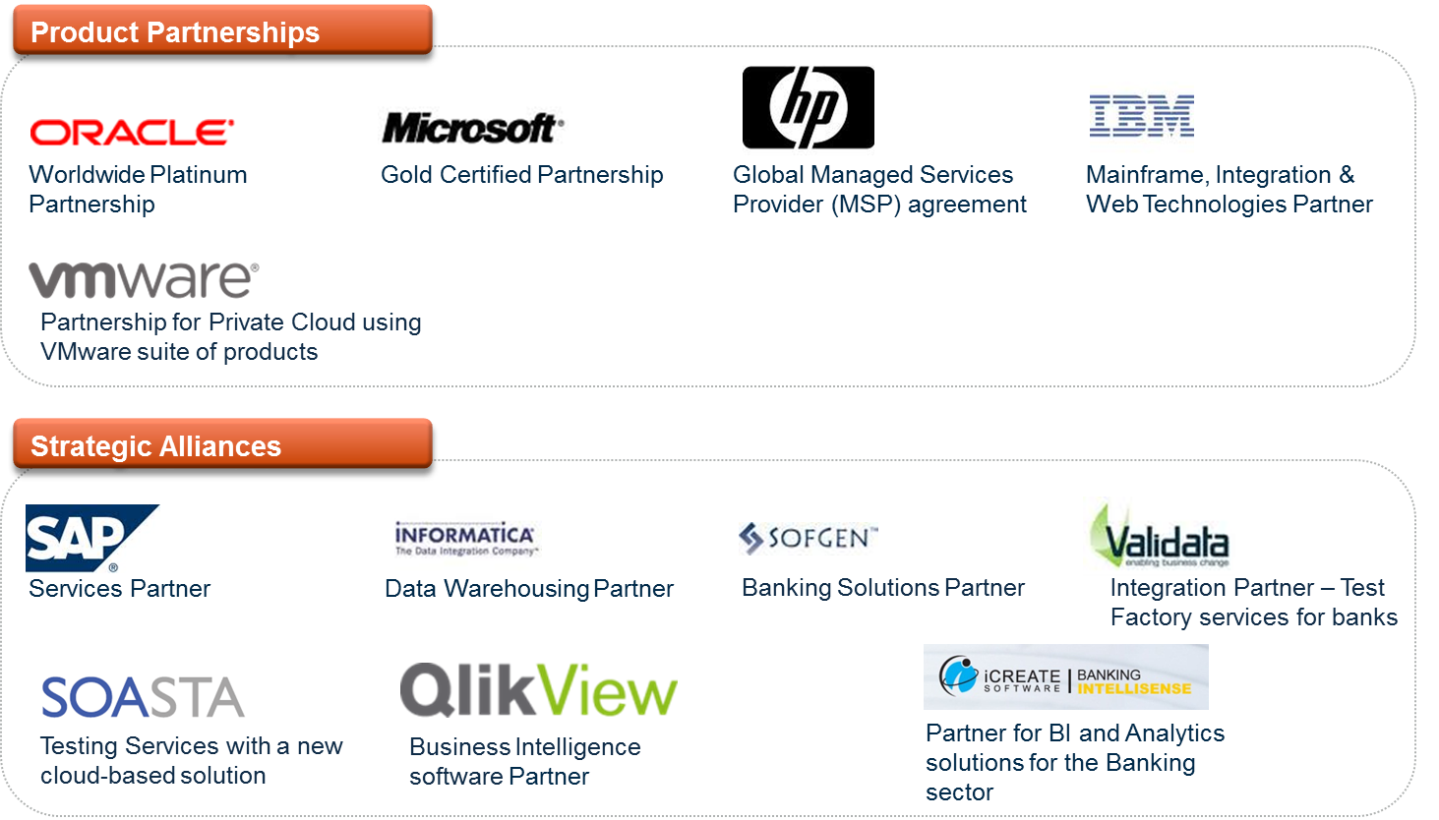

How many people does your company employ in the area requested? Explain the client break up by segment (ie: financial, medical and manufacturing) and revenue.

We help clients achieve a competitive advantage by co-developing innovative IT/ Process capabilities and ensure that they are delivered through flexible business models. We are **organized by domain** – we focus on and have achieved leadership positions in domains such as **Banking and Financial Services, Insurance,** Global Travel & Transportation and Emerging Markets.

|  |  |  |
| --- | --- | --- |
| **Domain** | **Clients** | **Resources** |
| **Banking and Financial Services, Insurance** | 70+ | 2500 |
| Global Travel & Transportation | 45+ | 1600 |
| Emerging Markets | 75+ | 4000 |

How many new clients and consultants have been brought onboard for 2011?

* 15 new clients added in Q4 2011; 51 in CY 2011 cutting across all focus areas
* Global Headcount increased to 8,317 at the end of December 2011; 1,806 employees added during the year 2011; Attrition declined sequentially to 13.9%

## User references

Need to replace this with QATS & JAVA

|  |  |  |  |
| --- | --- | --- | --- |
| **Customer** | **Engagement Description** | **Period** | **Effort** |
| **Leading Investment Manager** | * Back Office Accounting System Operations Support * Eagle PACE Data Warehouse Implementation and Support * EDM ODS Application Support * EDM Consulting and Downstream Implementation * Development of Index Platform Consolidation | 5 Years + | Team size 130+ |
| **Leading Global Custodian** | * Hexaware plays the role of a strategic partner by being involved in multiple tactical and strategic programs which include * 24 X 5.5 Application Support and Maintenance from Onsite (US) and Offshore (India) of enterprise applications like Eagle STAR, PACE, Mainframe Applications, Open technology applications * Development, Enhancement, Maintenance and Quality Assurance of business critical enterprise applications | 7 Years + | Team size 240+ |
| **Large Partnership Bank** | Hexaware supports across 32 active large projects across 25 internal departments on a wide spectrum of technologies and business platforms including SunGard, Eagle STAR, PACE, Corporate Actions, Swift, Mainframe, Java, Reporting Platform and PeopleSoft HR as a “long-term partner”.  Hexaware has additionally partnered to build core teams in Mercator, Lombardi, Cognos and ODI space. | 7 Years + | Team size 160+ |
| **A Leading US Private Bank** | Established Testing Center of Excellence  to perform IST/ UAT for a Leading US  Private Bank  Scope of Testing includes:   * **Functional Testing  -** System testing , System integration testing and User Acceptance testing , Scope includes  Test Design, Execution and   Implementation * **Data based Testing :** Comparison of  Front end with source and Target database * **Regression testing :** Regression Testing  of End-to-End business scenarios * **Non Functional  Testing :** Performance testing using Load runner * **Automation Testing :** Automated Testing  using Hexaware’s Accelerator Technology * **Environment Management :** complete ownership of environmental management   Business Benefits:   * A repeatable test automation suite that could be utilized during Regression Testing for subsequent release . This resulted in 60% saving of overall regression effort. * Early release of application for production usage post exhaustive testing and  critical defect fixing * Performance testing ensured user scalability aspects of the developed Application * Cost Optimization using Onsite offshore model | 2009- till date | Peak team Size-  Onsite- 9  Offshore- 80 |

***On CME’s request, Hexaware would facilitate the communication between Client and the above referred customers.***

# Exhibit a: Master Consultant Agreement

Attachment will accompany this RFI

# Exhibit B: InfoSEc Vendor Questionnaire

Attachment will accompany this RFI

# Exhibit C: Rate Card

1. Attachment will accompany this RFI